SIMATS ENGINEERING
ASSESSMENT TOOL 3 – Assignment 2

COURSE NAME: STATISTICS WITH R PROGRAMMING COURSE CODE: ITA04

COURSE OUTCOME COVERED

CO3: Construct and manipulate data frames using reshaping, merging, and file I/O operations in R to prepare structured datasets for analysis.. (BL3, BL5)

Assessment Tool Weightage: 20%

QUESTIONS: 5 Total Marks: 100

Annexure

Assignment 2

Code of Conduct:

I AJTTH M (Name / Reg No) certify that this submission is my original work and that I have adhered to the guidelines specified for this assessment.
I understand that any violation of academic integrity rules will result in disciplinary action.

Signature of the student: AJITH M

- Expense Category Bar Chart

Category <- c("Food", "Transport", "Shopping", "Bills", "Education")
Amount <- c(2500, 1500, 4000, 3000, 2000)

barplot(Amount, names.arg = Category,
main = "Expenses by Category",
xlab = "Category",
ylab = "Amount",
col = "skyblue")

OUTPUT:
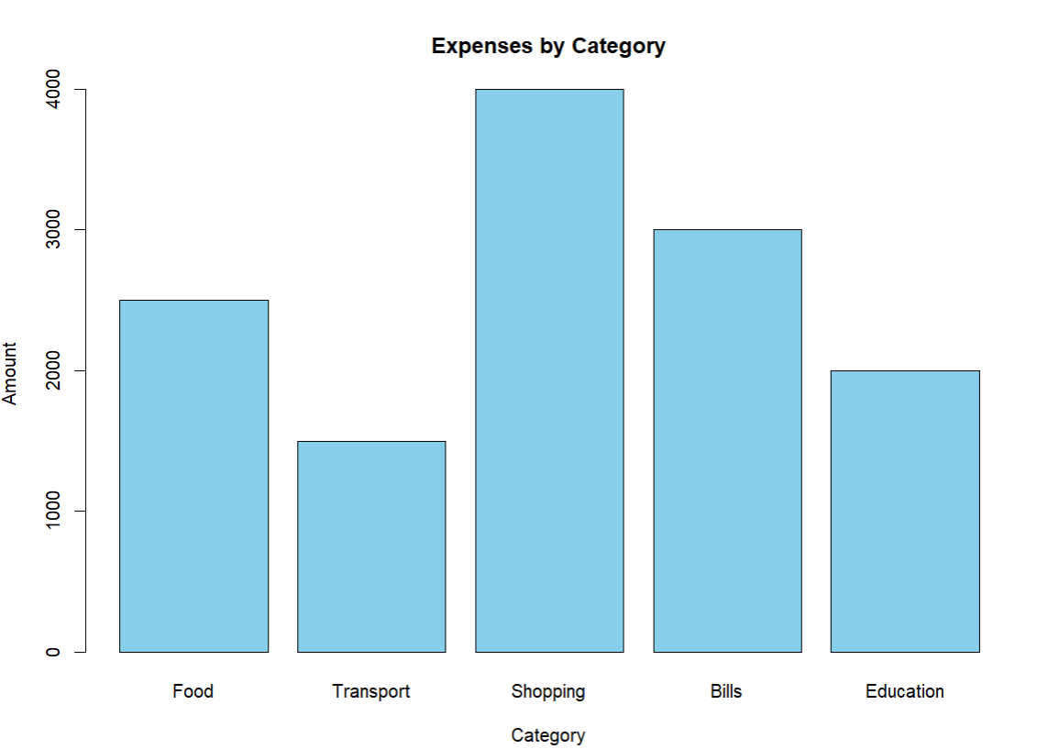

- Expense Distribution Pie Chart

Category <- c("Food", "Transport", "Shopping", "Bills", "Education")
Amount <- c(2500, 1500, 4000, 3000, 2000)

pie(Amount, labels = Category,
main = "Expense Distribution",
col = rainbow(5))

OUTPUT:
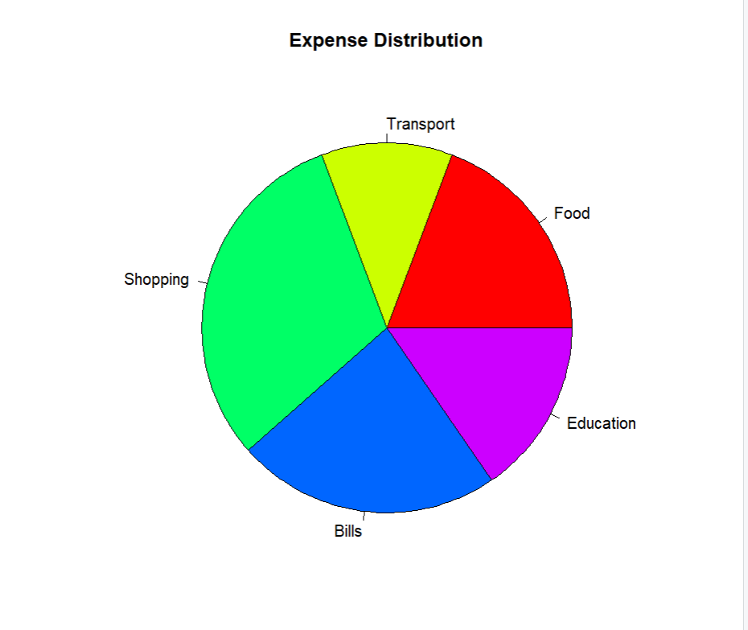

3. Monthly Expense Line Graph

Month <- c("Jan", "Feb", "Mar", "Apr", "May", "Jun")
Amount <- c(8000, 9500, 7000, 11000, 9000, 12000)

plot(1:6, Amount, type = "b",
main = "Monthly Expense Trend",
xlab = "Month",
ylab = "Amount",
xaxt = "n",
col = "blue")

axis(1, at = 1:6, labels = Month)

OUTPUT:
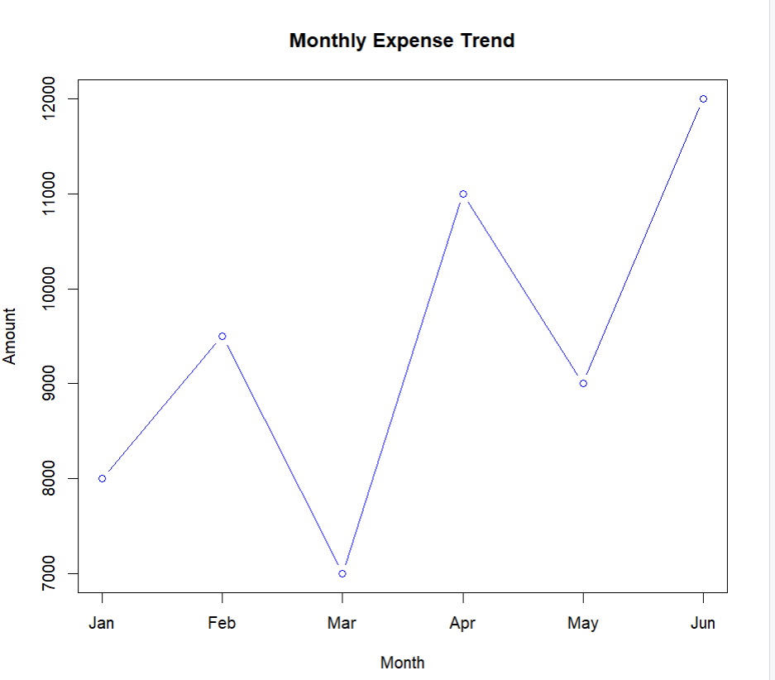

4.Payment Method Bar Chart :
Payment <- c("UPI", "Cash", "Card", "Debit", "Bank")
Amount <- c(6000, 2500, 8000, 4500, 3000)

barplot(Amount, names.arg = Payment,
main = "Expenses by Payment Method",
xlab = "Payment Method",
ylab = "Amount",
col = "orange")

OUTPUT:
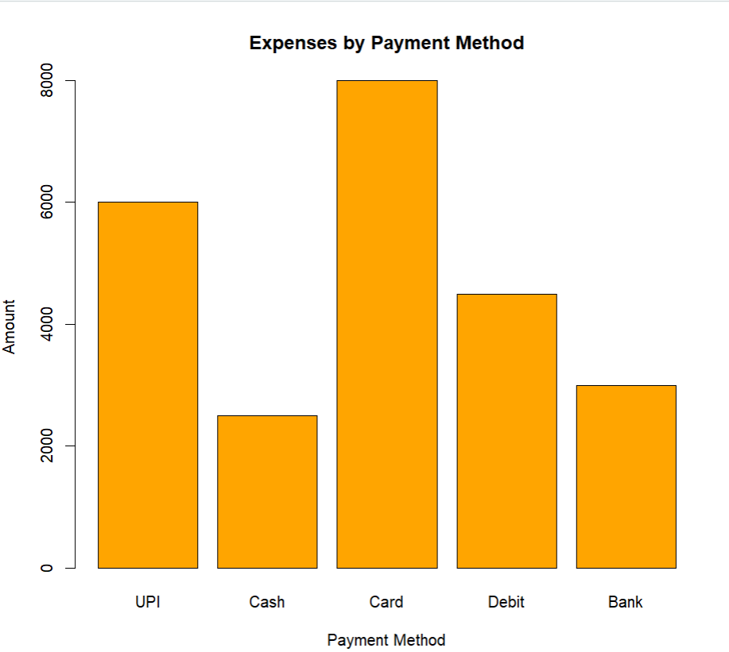

5. Category-wise Expense Box Plot
Food <- c(200, 350, 500, 800, 600)
Transport <- c(100, 250, 400, 600, 300)
Shopping <- c(500, 1200, 2000, 3000, 1500)
Bills <- c(800, 1000, 1500, 2200, 1200)

Data <- data.frame(Food, Transport, Shopping, Bills)

boxplot(Data,
main = "Spending Variation by Category",
xlab = "Category",
ylab = "Transaction Amount",
col = "lightgreen")

OUTPUT:
